Psalm 107 vv 1-3, 17-22 Common Worship Chant: Thomas Attwood

Chant on a single line of music:



Or, on two lines of music for copying into narrow columns:

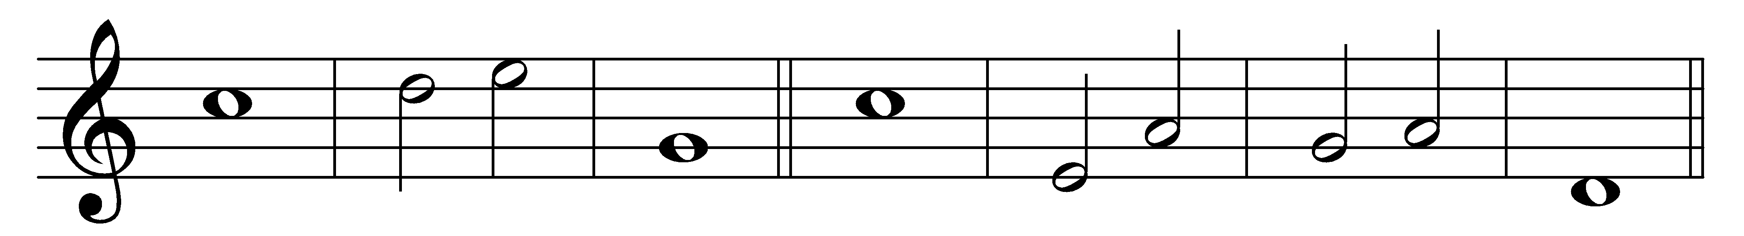

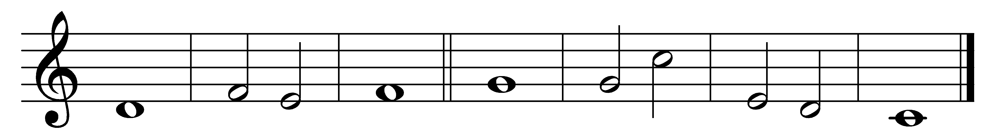

O give thanks to the Lord, for | he is | gracious,

for his steadfast | love en-|dures for | ever.

2 Let the redeemed of the | Lord say | this,

those he re-|deemed· from the | hand· of the | enemy,

*2nd part* 3 And gathered out of the lands from the | east and· from the | west,

from the | north and | from the | south.

17 Some were foolish and took a re-|bellious | way,

and were plagued be-|cause of | their wrong-|doing.

18 Their soul abhorred all | manner· of | food

and drew | near· to the | gates of | death.

19 Then they cried to the | Lord· in their | trouble,

and he de-|livered· them from | their dis-|tress.

20 He sent forth his | word and | healed them,

and | saved them | from de-|struction.

21 Let them give thanks to the | Lord· for his | goodness

and the | wonders· he | does· for his | children.

22 Let them offer him | sacrifices· of | thanksgiving

and tell of his | acts with | shouts of | joy.

Words taken from Common Worship © The Archbishops’ Council 2000.